Name – Akshat Bhargava

Roll no – 22563

DS – SL3

Prac 10

Code:

1. Download the Iris flower dataset or any other dataset into a DataFrame.(e.g.

https://archive.ics.uci.edu/ml/datasets/Iris). Scan the dataset and give the inference as:

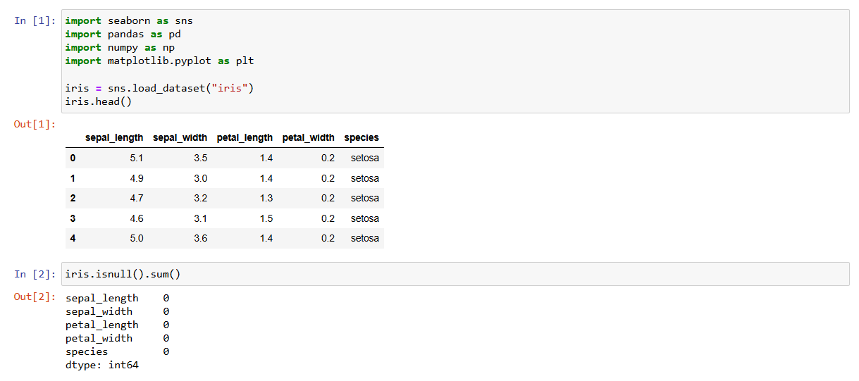

2. List down the features and their types (e.g., numeric, nominal) available in the dataset.

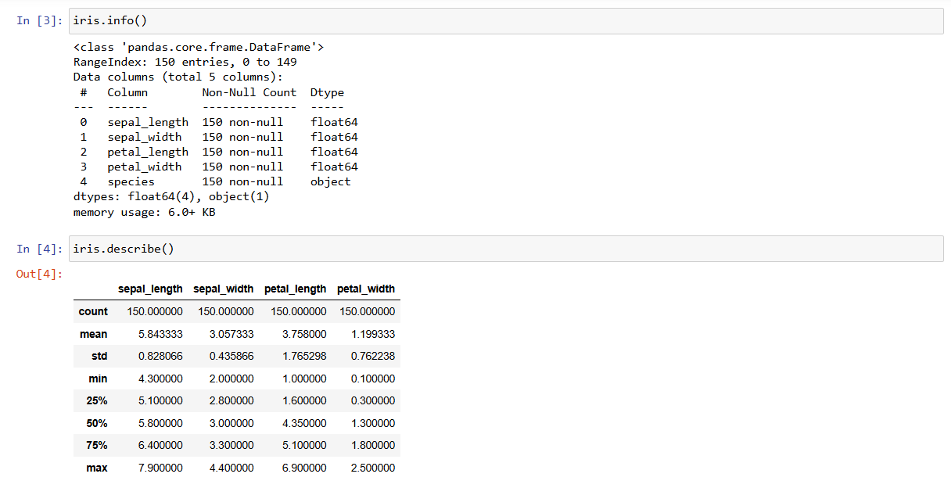

3. Create a histogram for each feature in the dataset to illustrate the feature distributions.

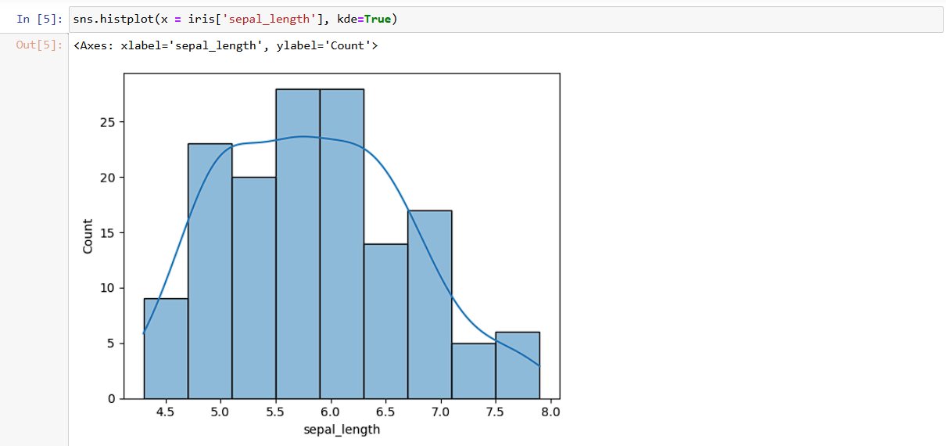

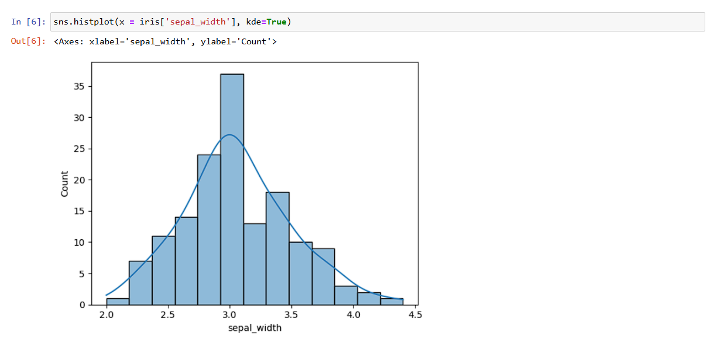

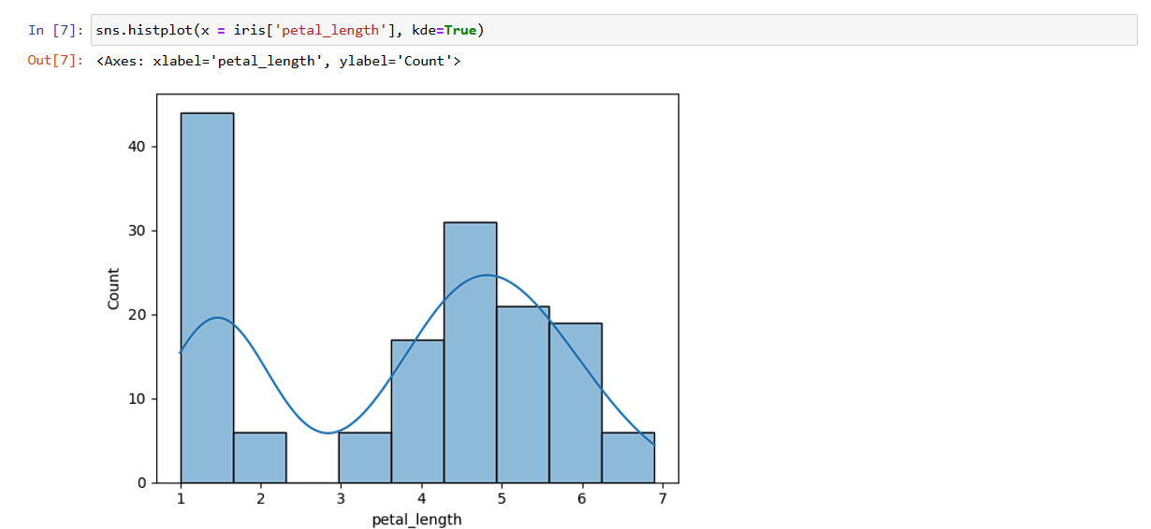

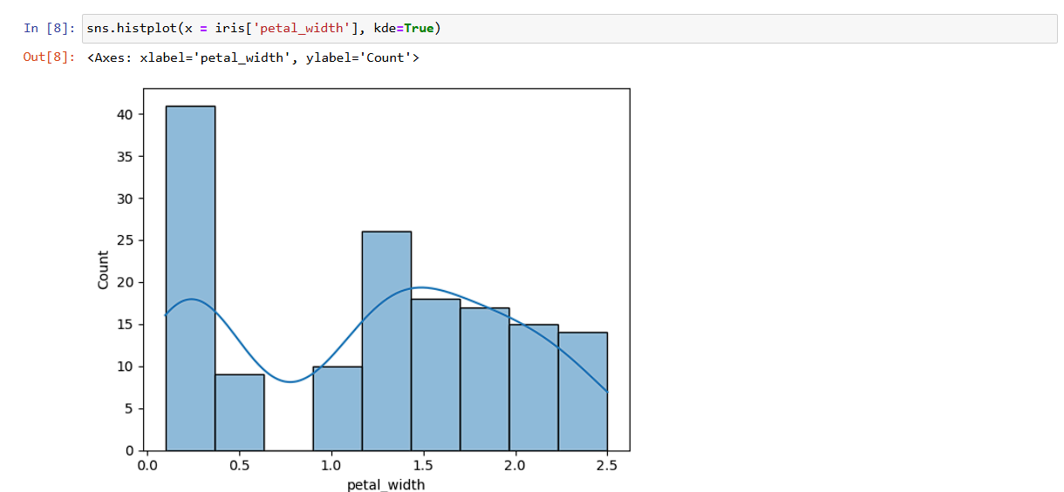

4. Create a boxplot for each feature in the dataset.

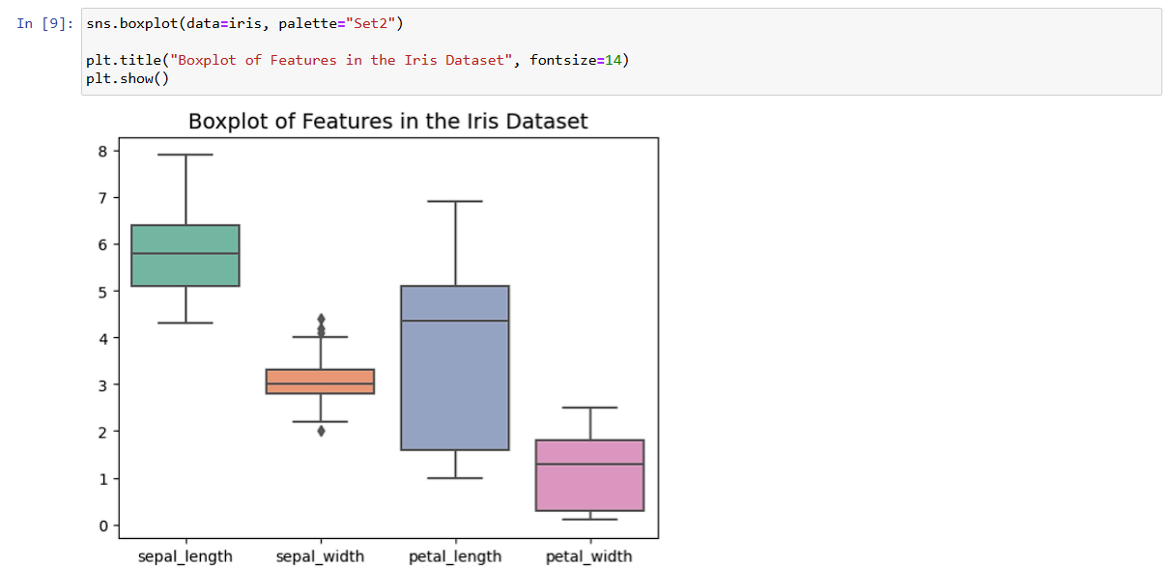

5. Compare distributions and identify outliers.

